Information Wiki

By

Pranshu

Level-6

Final Project

Table of Contents

Project Proposal 3

Goals and Objectives 3

Project Scope 3

Project Specifications 3

Target Audience 3

Project Deliverables 4

Resource Requirements 4

Project Tasks and Milestones 4

Project Assumptions 4

Project Report 5

Detail Design 5

Home Page 5

Author Registration Page 6

Login Page 6

Viewer Registration Page 7

Author Information Page 7

Wiki Pages 7

Viewer Information Page 8

Wiki Pages Viewer 8

Project Testing 9

User Manual 9

Summary 9

System Configuration 9

User Access Levels 9

# 

# Project Proposal

## Goals and Objectives

Information wiki is an online ASP.net based application which is implemented to create and share the knowledge. In this application there are two types of users- authors and viewers. Authors can edit, delete, and access details of their accounts. Also, new authors can register with the web application for free. Also, authors can add new wiki pages of information, view, edit and delete their added pages.   
One author can only view the pages added by other authors. On the other side, viewers can edit, delete, and access details of the viewer. Viewers can view wiki pages.

## Project Scope

The scope of this project is to implement an app named “Information wiki” with the help of which users can create and share knowledge. The duration of the project is 20 working days which equals to 4 weeks.

## Project Specifications

* Author login/logout
* Edit, delete, and check details of authors.
* The authors can add new wiki pages.
* Authors can only view other authors wiki pages.
* Authors can view, edit, and delete their wiki pages.
* Viewer login/logout.
* New viewers can register.
* Viewers can edit, delete, and access details of their information.
* Viewer can view wiki pages

## Target Audience

The target audience for this project is the knowledge of loving people who love to create and share knowledge. The age can go from 7 plus to 100 plus.

## Project Deliverables

The deliverables of the project are:

|  |  |
| --- | --- |
| **Deliverable** | **Description** |
| Final Report | This will be the final report of the project. |
| Coding | The executable code of the project will go under this. |
| Documentation | This portrays the documentation of the project. |
| Testing | All the test details will be covered in this part. |

## Resource Requirements

* Windows Operating System 10.
* Microsoft word and excel for documentation.
* Asp.net MVC Framework
* 64-bit processor and 4 GB or more RAM
* Identity framework- ASP

## Project Tasks and Milestones

|  |  |  |  |  |
| --- | --- | --- | --- | --- |
| **Tasks** | **Week-1** | **Week-2** | **Week-3** | **Week-4** |
| Brainstorming and analysis |  |  |  |  |
| Planning and initial meeting Project Proposal document. |  |  |  |  |
| Database Design and UI Design |  |  |  |  |
| Identity framework implementation |  |  |  |  |
| Coding for admin and reporter |  |  |  |  |
| Testing |  |  |  |  |
| Final Documentation and closing |  |  |  |  |

## Project Assumptions

Following is the assumption made while implementing the project:

* One author and viewer will be registered by default.
* The application will be free and open source.

# Project Report

#### Functional and Non-Functional

|  |  |
| --- | --- |
| Users | Functional |
| Author | * Login/logout * Register a new author. * The author can add new wiki pages and manage their wiki pages by editing, deleting. * The author can only view other authors wiki pages. * Authors can edit, delete, and access details of their accounts. |
| Viewer | * Can view wiki pages. * Can edit, delete and access details of their accounts * New viewers can register for free. * Login using valid credentials |
|  | Non- Functional |
|  | * High speed * Fast Loading time * High performance and security * All browsers compatibility. |

## Detail Design

### Home Page

The main landing page of the application. On navigation bar options are- home, Wiki Pages, Viewer Registration, Author Registration and login.



### Author Registration Page

With the help of this page, new authors can sign up for the app

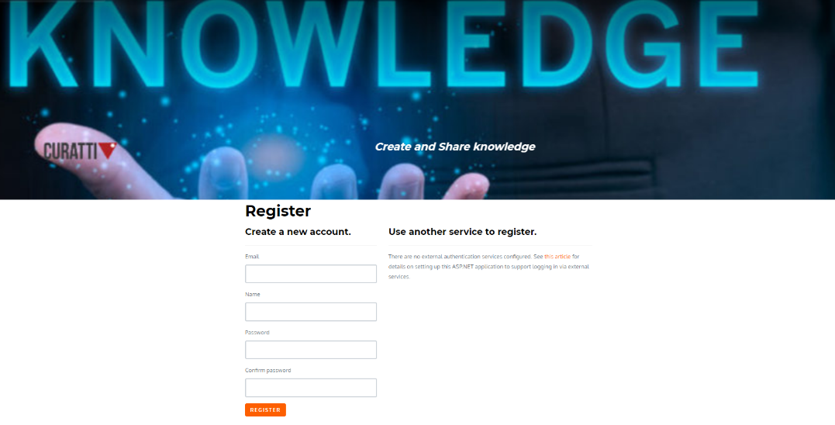

### Login Page

With the help of this page, the author and viewer can login to the application using their valid credentials.

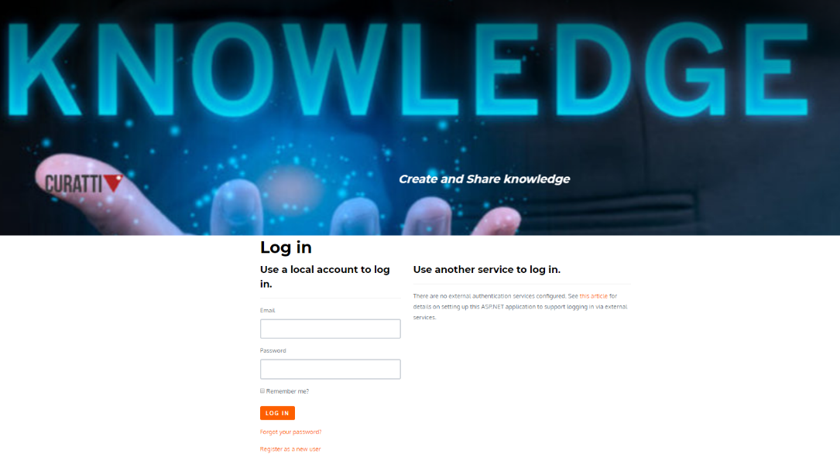

### Viewer Registration Page

With the help of this page new viewers can register for the app for free.

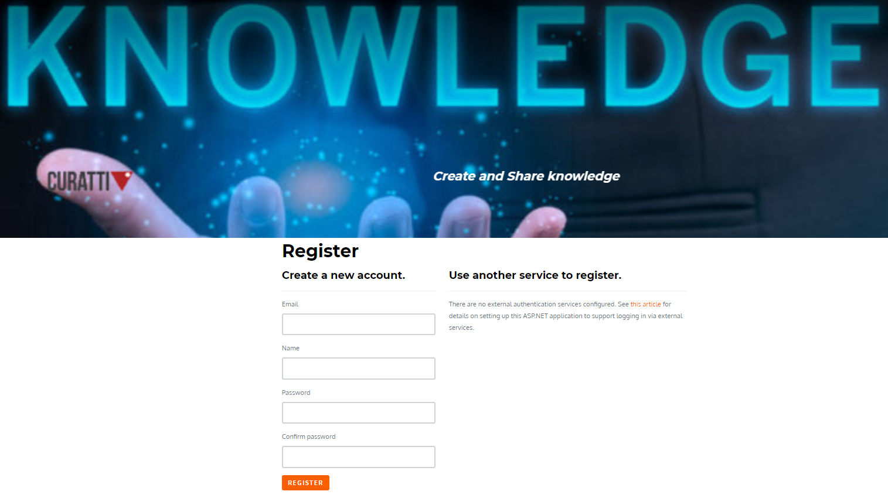

### Author Information Page

With the help of this page authors can manage their accounts by editing, deleting, and checking their details.

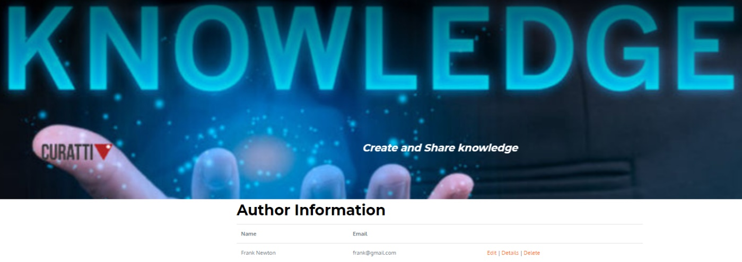

### Wiki Pages

With the help of this page authors can add new wiki pages and view other authors wiki pages and manage their wiki pages.

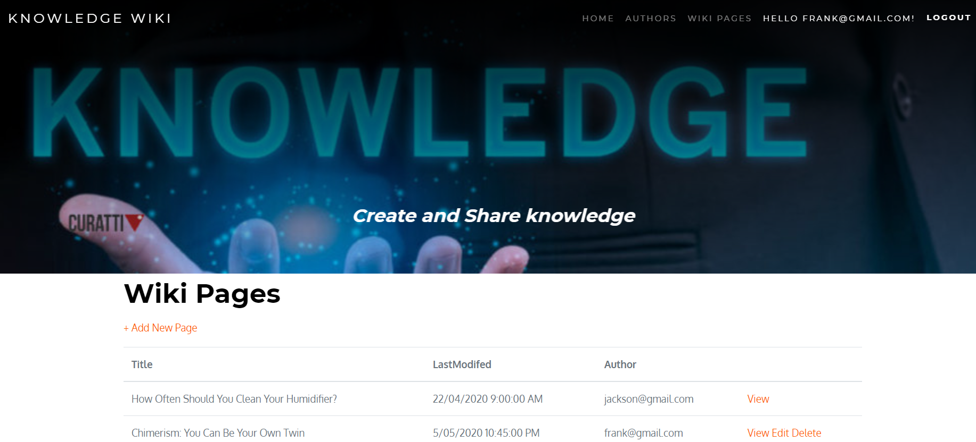

### Viewer Information Page

With the help of this page viewers edit, delete, and access details of their account.

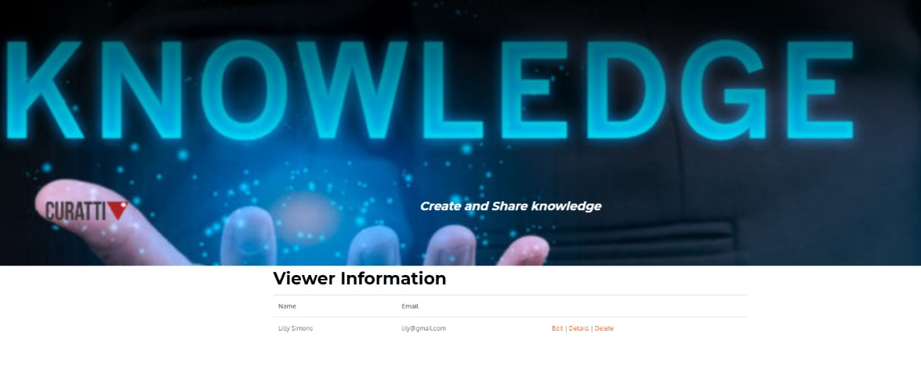

### Wiki Pages Viewer

With this page viewers can view the wiki pages.

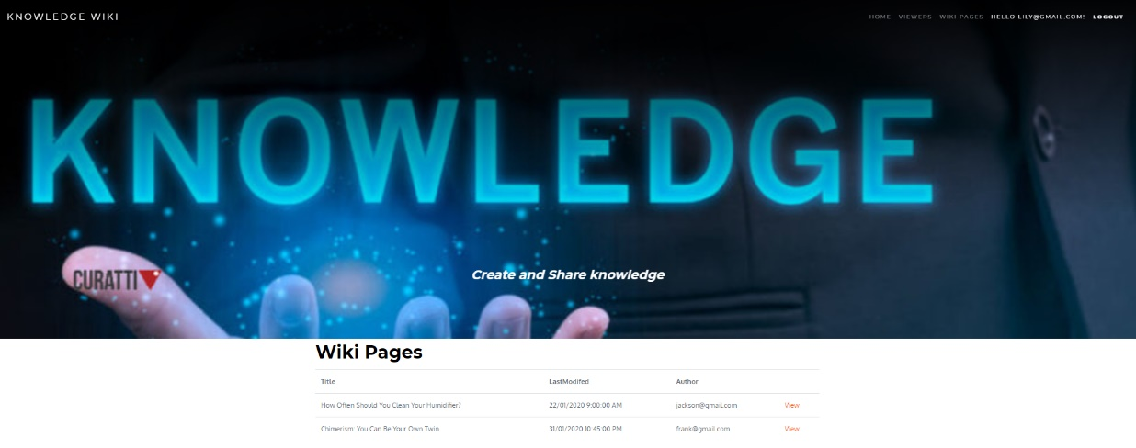

## Project Testing

The testing file for usability testing is attached as [Information Wiki.xlsx](Information%20Wiki.xlsx)

## User Manual

Information wiki is an online ASP.net based application which is implemented to create and share the knowledge. In this application there are two types of users- authors and viewers. Authors can edit, delete, and access details of their accounts. Also, new authors can register with the web application for free. Also, authors can add new wiki pages of information, view, edit and delete their added pages.   
One author can only view the pages added by other authors. On the other side, viewers can edit, delete, and access details of the viewer. Viewers can view wiki pages.

## Summary

### System Configuration

This app will be useful to share and create knowledge.

### User Access Levels

Only registered users can access the features of this application.

* **Authors:** Authors have full access to their accounts and wiki pages. They can only view other wiki pages. Also can add new wiki pages.
* **Viewers:** New viewers can register and existing can login using their credentials. They have limited access.